Battery Voltage Virtual Gauge Display – CGEA1.3

Functional Description
The purpose of the Battery Gauge is to inform the driver of the vehicle’s battery voltage. It is not a linear indication of battery voltage.

The Hot at all Times (B+) input to the cluster is the input sensed to determine gauge position. This input is filtered and translated into a numerical value and a pointer position on the virtual battery gauge (voltmeter).

There is a digital numeric display and graphical virtual gauge that displays the vehicle’s battery voltage. The battery voltage virtual gauge display pointer shall rotate from bottom to top or left to right to register increasing voltage and rotate in the opposite direction for decreasing voltage.

The virtual gauge display portion of this STSS is applicable only on clusters that have the capability to display it. Clusters with “B”, “E” or “F” displays implementing this feature shall only display the numerical value of the battery voltage.

Interfaces

Interface Context Diagram (I/O Block Diagram)
Engine Coolant Temperature Gauge Display Context Diagram

Inputs

IR-REQ-297249/A-Internal
- Operational_Mode
- Battery_Voltage_display_Cfg
- Hot at all times (B+) (HW)

IR-REQ-297250/A-Outputs
- Battery Voltage Numeric Display
- Battery Voltage Virtual Gauge Indication

Function/Performance

F-REQ-297251/A-Operational Modes

Mode | Differentiating Vehicle Conditions
Sleep Mode | Battery Voltage Display / virtual gauge indication inactive
Limited Mode | Battery Voltage Display / virtual gauge indication inactive
Normal Mode | Battery Voltage Display / virtual gauge indication active
Crank Mode | Battery Voltage Display / virtual gauge indication active

Voltage Levels
Refer to the Cluster Features table located in the Operational Modes and Voltage Range Strategies Section of this SPSS.

Human-Machine Interface

Visual

Indicator Graphics / Display Format

“B”, “E” or “F” Displays Reference
  - For “B”, “E” or “F” displays, please refer to the Message Center_BEF Displays_3 Button Interface STSS and the Text Message List – BEF Displays 2x14.xls file.

TFT Display Graphics Reference
  - For TFT display graphics, refer to approved studio PNG data. Below is an example:

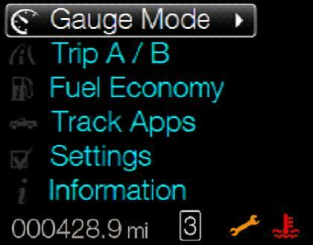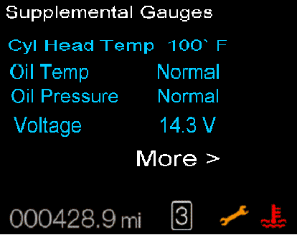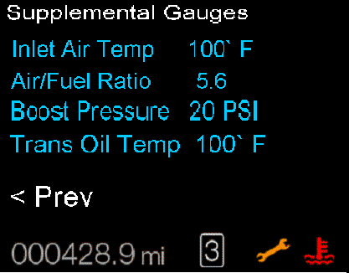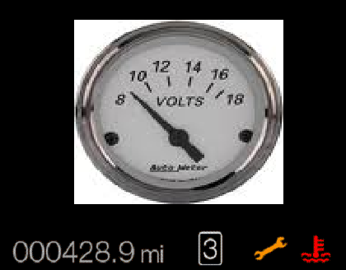

Indicator Color Coordinates
None

HMI-REQ-297252/A-Indicator Characteristics

Description of Gauge | Scale Range | Scale Span on virtual gauge | Operating Span
North American | 8 to 18 Volts | 0 -120 angular degrees | 0 - 120 angular degrees

Audio
None

Switch Control Logic
Not Applicable

PFM-REQ-297253/A-System Accuracy

- Shall indicate within 100 msec the calculated Filtered_Voltage_Value, which is the value of the Hot At All Times input after filtering.

Operation: Performance and Functional

Subsystem Algorithm Flowchart / State Diagram

F-REQ-297390/A-Numeric Gauge Flow Chart

F-REQ-297391/A-Virtual\Numeric Display
The virtual gauge portion is not applicable on clusters with “B”, “E” or “F” displays. Only applicable on clusters that have capability to display virtual gauges.

F-REQ-297392/A-Virtual Gauge Flow Chart

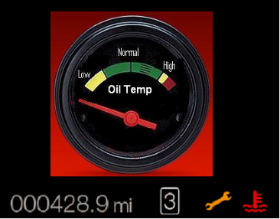

Operation Description (supports algorithm flowchart /state diagram)

F-REQ-297254/A-Filtered Voltage Value
- Filtered_Voltage_Value is the values of the Hot at All Times input as sensed at the micro with an averaging filter applied that has a time constant of 0.5 to1 second.

F-REQ-297255/A-Filtered Voltage Value Hysterisis
- A 0.5 volt hysterisis (configurable from 0 to 1.0 volts in 0.5-volt increments) shall be applied to the Filtered_Voltage_Value to prevent the pointer from rendering small changes in the battery voltage display.

F-REQ-297256/A-Digital Display Value Ranges
- Digital display value ranges to follow this strategy:
- if voltage is 12.0 – 12.25, display 12.0.
- if voltage is 12.26 – 12.75, display 12.5.
- if voltage is 12.76 – 13.25, display 13.0.

F-REQ-297257/A-Gauge Needle Waver
- The Battery Voltage virtual gauge display shall not exhibit needle waver exceeding 1/3 of an angular degree with a steady commanded input.

F-REQ-297258/A-Gauge Needle Movement
- The Battery Voltage virtual gauge needle shall have a smooth movement between the voltage ranges.

F-REQ-297259/A-Pointer Overshoot Limit
- Pointer overshoot indicated by Filtered_Voltage_Value shall not exceed one angular degree.

F-REQ-297260/A-Gauge Pointer Position Update Rate
- The cluster shall update the virtual gauge pointer position at least once every 1000 msec.

F-REQ-297261/A-Battery Voltage Display Configuration
- The Battery Voltage display and the virtual gauge shall not be displayed if Battery_Voltage_display_Cfg is Disabled (0x0).

FS-REQ-297264/A;1-Function Safety Classification (EMC)

B

NVM-REQ-297265/A-Memory Storage

Parameter Name | Description | Value at  Battery Connect | Value at  Module Wake-up
Battery Voltage numeric display | Used to display the numeric value of the vehicle’s battery voltage. | Inactive | Inactive
Battery Voltage virtual gauge indication | Used to display vehicle’s battery voltage on a virtual gauge display | Inactive | Inactive
Filtered_Voltage_Value | Filtered value of Voltage_Value | 0 | 0
Battery_Voltage_display_Cfg | State indicator for feature presence controlled via CAN at EOL at VO plant. Set to Disabled at Cluster Supplier Manufacturing Plant | Use Stored Value | Use Stored Value
Operational_Mode | 4 state indicator for cluster operational mode | Limited | Limited, Normal or Crank

Prove Out
No

Error Handling
None.

Missing Message Strategy
None

Diagnostics

Self Test
None

Engineering Test Mode
Reference section “Dealer / Engineering Test Mode (ETM)”

Part II Performance

Supported Diagnostic Trouble Codes (DTCs)
None.

DID-REQ-297266/A-DID DE00

Block  Num | Block Description |  | Size (bits) |  | Byte |  | Bit |  | State: Description |  | "0" |  | "1" |  | Default |  | Comments
PACKETED BLOCKS
$00 | Option Content (B&A) |  | 1 |  | * |  | * |  | Battery Voltage Display |  | Disabled |  | Enabled |  | Disabled
*Byte and bit location to be identified in Part II Specification for this cluster

Reference Specification

- Func. Criticality EC-0048
- Mod. PWR-up / Reset EC-0049
- Low-High Vol. Perform. EC-0058
- Jump Start EC-0062
- Instr. & Gauges (indic. Grad) IS-0015
- Oper. Voltage Perf. IS-0052
- Oper. Voltage Func. IS-0053
- Sys. Audible Noise IS-0103
- Pointer Waver IS-0108
- Instr. Scale Dir. IS-0127
- Symbol Usage 01-0238 / 01-0239
- Symbol Leg. 01-0240
- Placement - Parts Loc. 03-0001
- Glare/Reflections 16-0068
- Reflection 17-0018
- Harmony: Graphics / Font / Ill. 17-0040
- Ergo - Access. 17-0052
- Ergo - Operablility 17-0053
- Control & Display Loc. 17-0060
- Logical grouping Function and Usage 17-0062
- Assoc. of Controls with Disp. & elem. 17-0063
- Ill. Controls & Disp. 17-0074
- Id. Legibility 17-0081
- ID. Coding / Labeling 17-0083
- Logic of Op. 17-0120
- Op. Stereotypes 17-0121
- Interpretation 17-0122
- Feedback 17-0124

Revision History
SPSS Module Revision History

Revision Level | Name | Change Description | Date
1.0 | V.Patel | Initial release for CGEA 1.3, based on “Battery Voltage Gauge Display S197” STSS version 1.2 dated Jan 18, 2012. | 10/18/2012
1.1 | Mlenkner | Changed Virtual_Gauge_Cfg to Battery_Voltage_display_Cfg throughout | 12/11/12
1.2 | V. Patel | This update does not contain any changes to functionality of the feature.  Section 1.3.3.1.1 Added a bullet point item referring to the BEF display requirements for support on clusters with BEF displays.  Section 1.3.5.1: Added a note above the virtual gauge processing that the virtual gauge portion does not apply to clusters with A or BEF type displays. | 5/8/2013
1.3 | A. Mishra | Initial VSEM Requirement Document | 02/19/2018

